 

LEASE MANAGEMENT

# PROJECT OVERVIEW:

The Lease Management System is an innovative solution designed to revolutionize how lease agreements are handled. It centralizes all lease-related operations, providing a streamlined approach to managing agreements, tracking payments, and ensuring compliance. This system addresses key challenges such as manual errors, inefficiencies, and lack of visibility by offering an intuitive, data- driven platform. With features like automated alerts, real-time updates, and detailed reporting, it supports seamless lease lifecycle management from initiation to renewal or termination.

The solution is tailored to enhance operational efficiency, reduce administrative burdens, and improve decision-making by providing stakeholders with actionable insights. It ensures transparency and consistency, helping businesses focus on strategic objectives without being bogged down by operational complexities.

### Technical Approach:

The Lease Management System uses a central database to store and manage lease data for easy access. It automates tasks like payment reminders and compliance checks to save time and reduce errors. The system updates data in real- time, so users always have the latest information. It is designed to be flexible, allowing future upgrades. A simple, user-friendly interface ensures easy navigation, while security features protect sensitive data.

### Benefits:

* **Time Efficiency:** Automates repetitive tasks to reduce manual input.
* **Accuracy:** Minimizes errors with automated data processing.
* **Centralized Data:** Provides a single, clear dashboard for lease information.
* **Scalability:** Supports business growth by handling an increasing number of leases.

 

# OBJECTIVES:

This section outlines the specific, measurable goals the Lease Management System project intends to achieve. These objectives are designed to address business needs, enhance operational processes, and deliver a clear, impactful solution for both property managers and tenants.

## Business Goals:

### Simplify Lease Management:

The goal is to create an easy-to-use system to manage lease agreements, tenant details, and property information, reducing manual work and organizing the process.

### Improve Data Security and Access:

The system will securely store tenant and property data and ensure that only authorized users can access or change it.

### Automate Lease Renewal and Termination:

The system will send automatic reminders for lease renewals and termination dates to keep everyone on track.

### Track Payments Efficiently:

It will track rent payments and due dates, giving property managers clear insights into payment histories and financial data.

## Specific Outcomes:

### Easy-to-Use Interface:

The system will have a simple, intuitive interface for both tenants and property managers to easily access and update information.

### Automated Alerts:

The system will send reminders for important dates, such as when rent is due or when a lease needs renewal.

 

### Real-Time Updates:

Lease information will be updated instantly, so users always have the most current data available.

### Generate Reports:

Property managers can generate reports to review lease details, payments, and property performance.

### Online Payment Integration:

The system will allow tenants to pay rent online, making the process easier for everyone involved.

### Scalable Design:

The database will be designed to handle more tenants and properties as the system grows.

# SALESFORCE KEY FEATURES AND CONCEPTS UTILIZED:

## Custom Objects and Fields:

* Custom Objects: Custom objects are used to store lease-related data, such as Tenant c, Lease c, and Property c, enabling tailored data management and organization for the Lease Management system.
* Custom Fields: Custom fields are created on standard or custom objects to capture additional information specific to the lease management process, such as lease start/end dates, payment due dates, and maintenance request details.

 

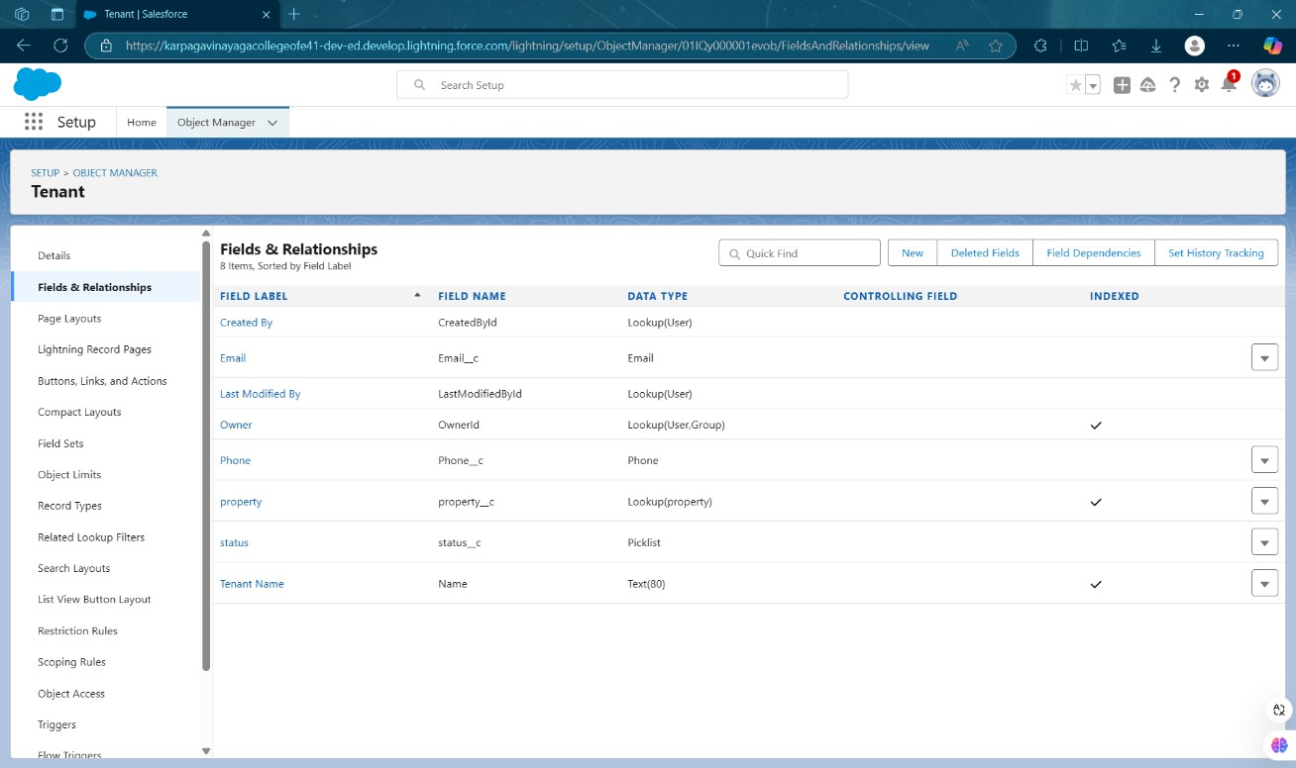

**Fig 1.1: Custom Object - Tenant**

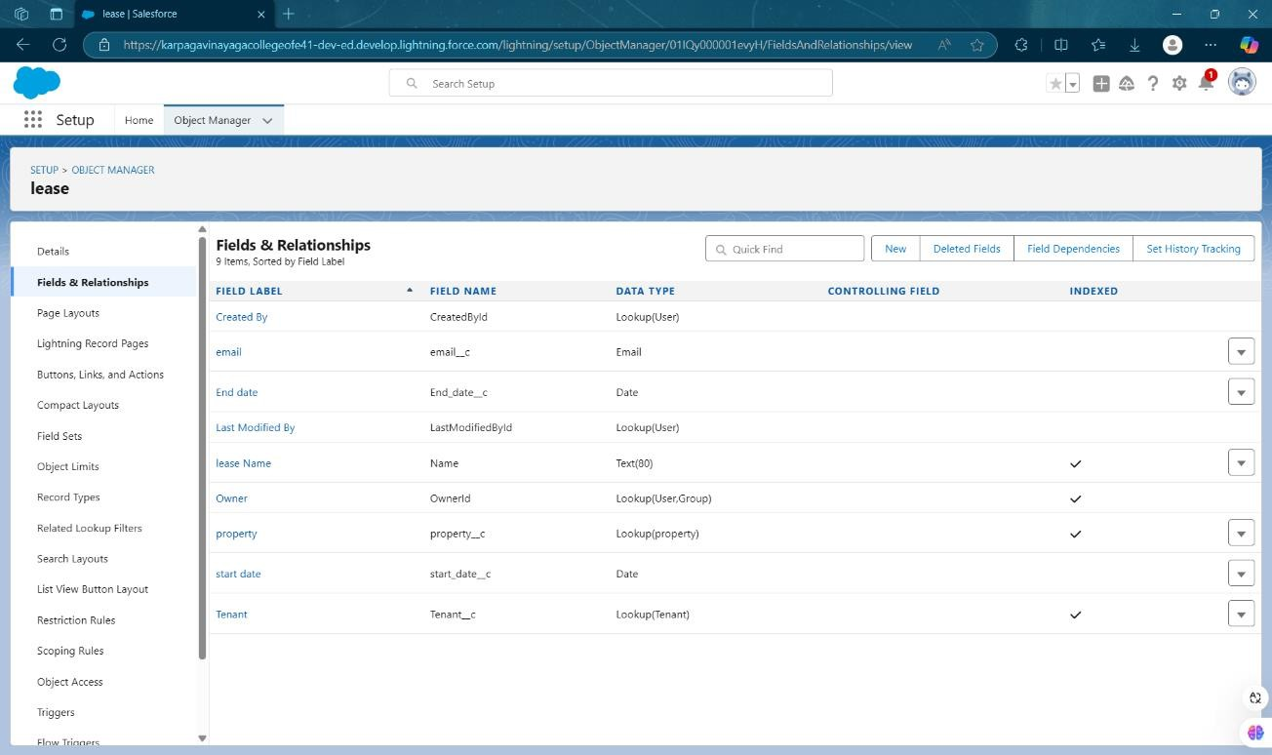

**Fig 1.2: Custom Object - Lease**

 

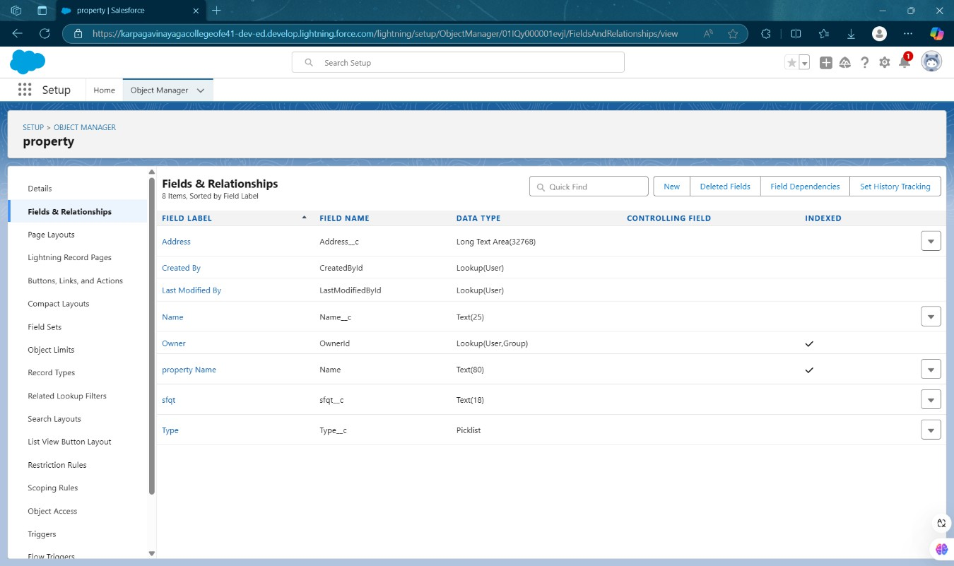

**Fig 1.3: Custom Object - Property**

## Automation with Workflow Rules and Process Builder:

Workflow Rules and Process Builder are used to automate key tasks. For instance, reminders for upcoming lease renewals and rent payments are

automatically sent to tenants and property managers. This reduces manual intervention and ensures timely actions, such as email alerts for overdue payments.

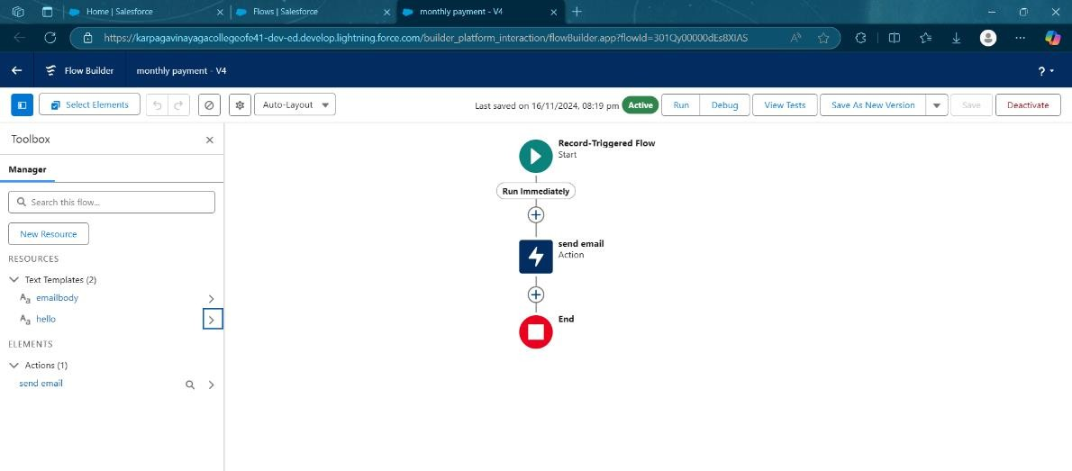

**Fig 1.4: Monthly Payment-Workflow**

 

## Reports and Dashboards:

Reports in Salesforce allow property managers to track lease data, payment statuses, and maintenance requests. Dashboards provide a visual representation of the data, making it easier to monitor and analyze important metrics like overdue payments, lease renewals, or upcoming maintenance tasks.

## Security and Access Control:

Salesforce ensures data security through role-based access control and sharing settings, allowing property managers and tenants to only access information relevant to them. This guarantees that sensitive data, such as tenant payment details, is protected and accessible only to authorized users.

## Email Communication and Templates:

* **Email Templates:** Use Salesforce to create email templates for automatic messages, such as lease renewals, payment reminders, and maintenance updates.
* **Email Alerts:** Salesforce sends email alerts automatically for important events, like upcoming payments or lease expirations.

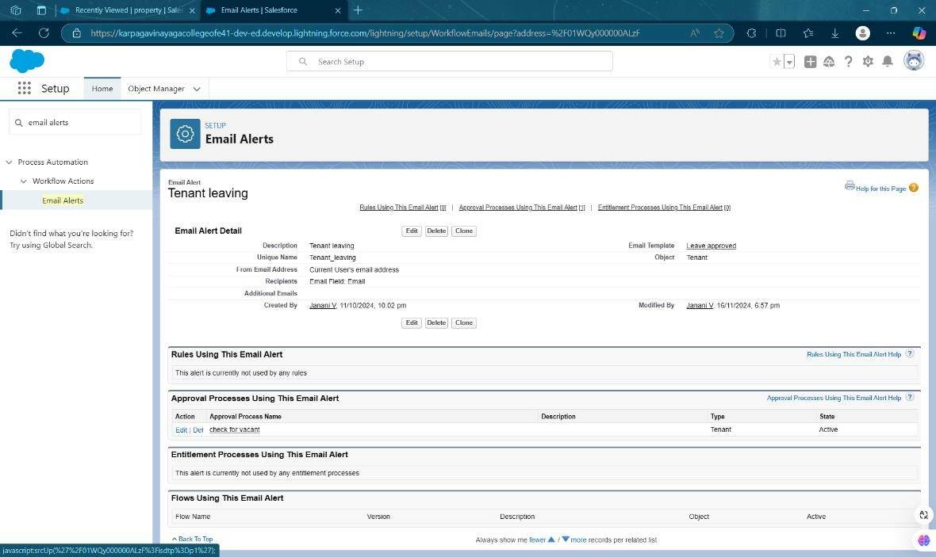

**Fig 1.5: Email Alerts – Tenant Leaving**

 

# DETAILED STEPS TO SOLUTION DESIGN:

This section outlines the step-by-step process of designing the Lease Management System. The design process focuses on creating a scalable, user- friendly, and efficient system that caters to property managers, tenants, and landlords. Each aspect is documented with detailed explanations and visuals.

## Data Models Design:

The data models are created to organize key information:

* **Tenant:** Stores tenant details like name, contact information, and lease dates.

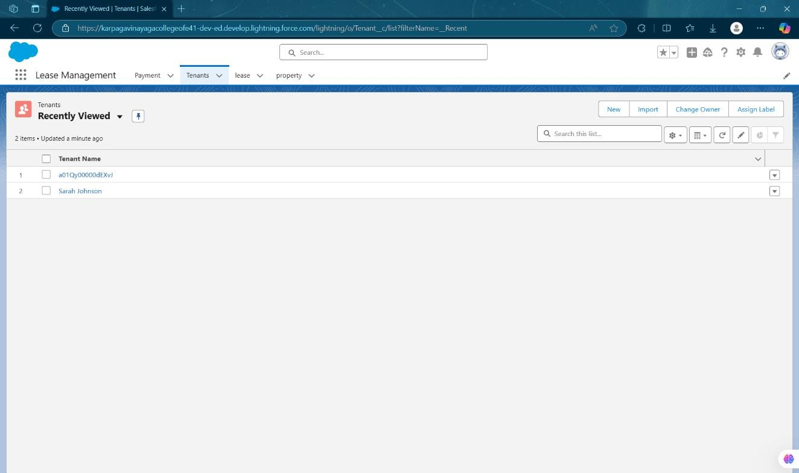

**Fig 1.6: Lease Management - Tenant**

 

* **Lease:** Tracks lease information such as start/end dates, rent amount, and status.

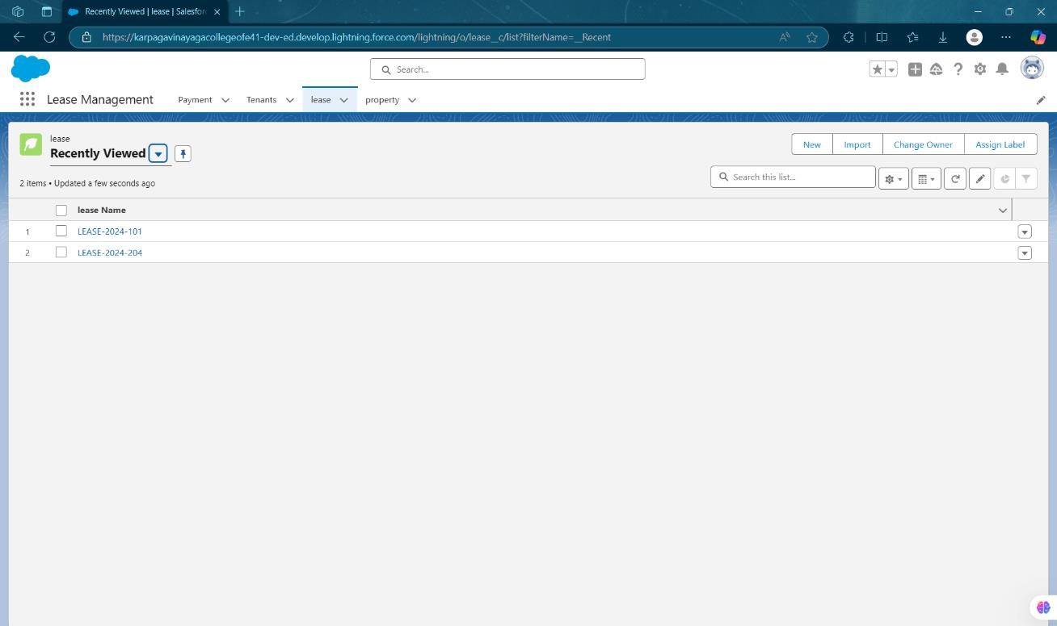

**Fig 1.7: Lease Management - Lease**

* **Property:** Contains property details like address, type, and owner information.

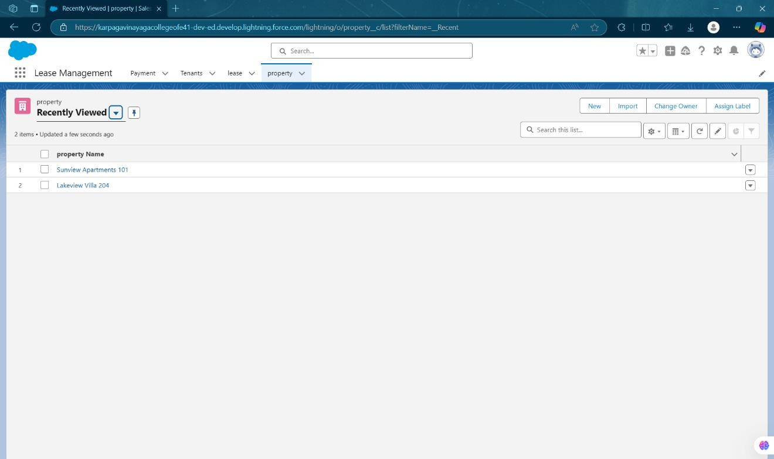

**Fig 1.8: Lease Management - Property**

 

### Relationships:

* + A tenant can have multiple leases.
  + A property can have multiple leases.
  + Each lease is linked to one tenant and one property.

## User Interface Designs:

The user interface (UI) is designed to be simple and user-friendly:

### Tenant Dashboard:

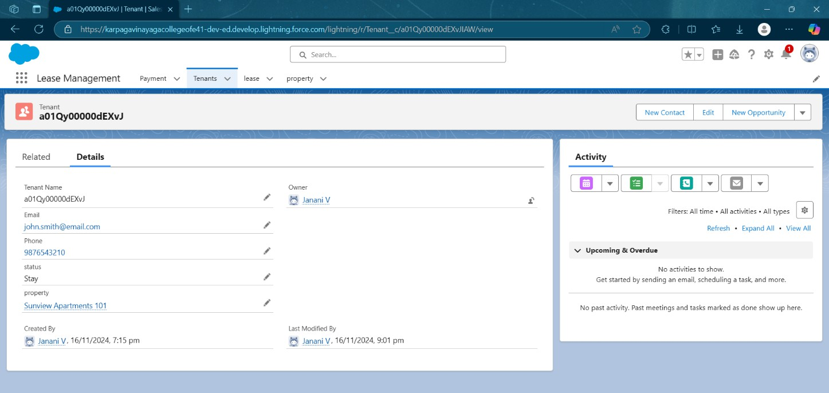

**Fig 1.9: Lease Management – Tenant Dashboard**

Shows an overview of the tenant's lease, payment due dates, and alerts for upcoming events.

 

### Property Manager Dashboard:

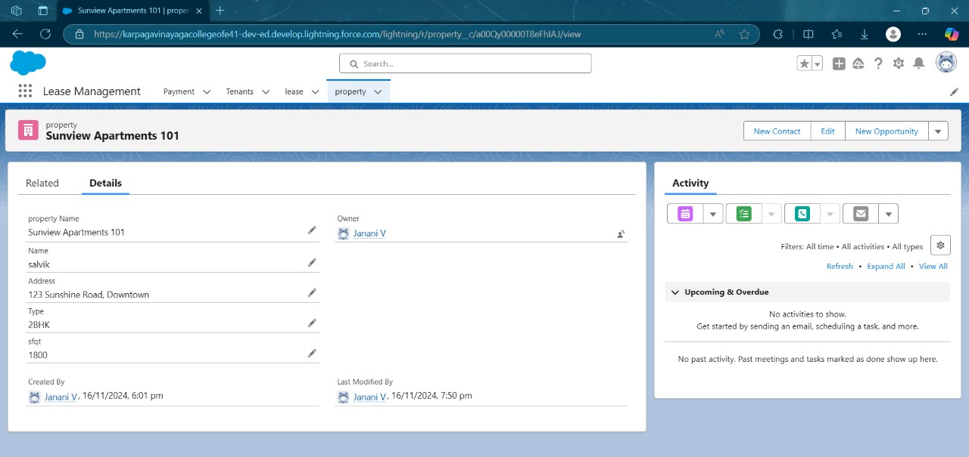

**Fig 1.10: Lease Management – Property Dashboard**

Displays all lease information, payment statuses, and maintenance requests.

### Lease Details Page:

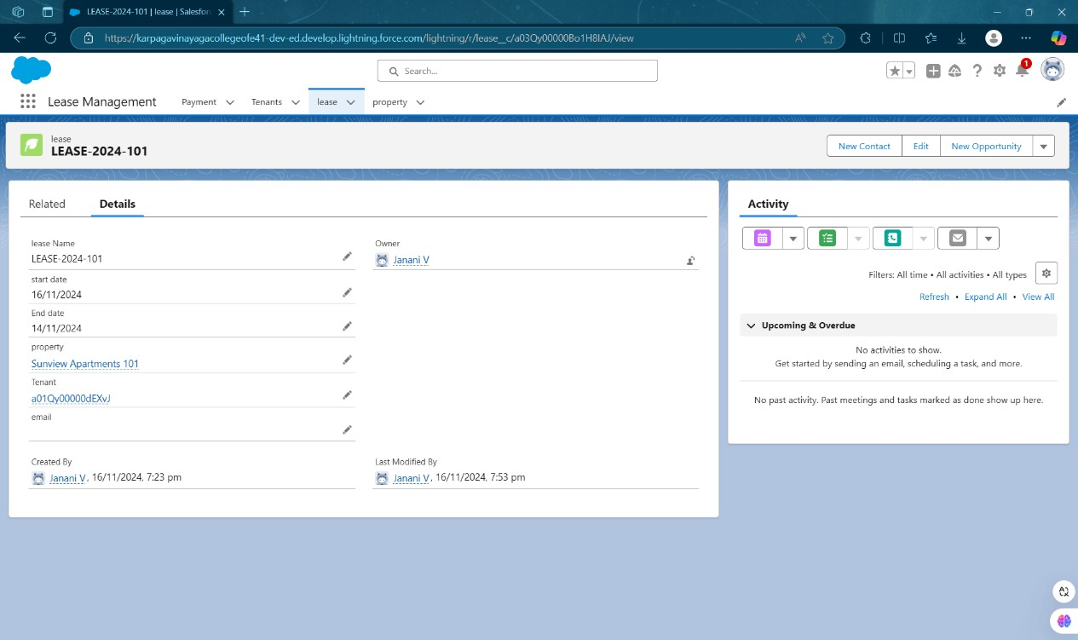

**Fig 1.11: Lease Management – Lease Details Page**

Shows detailed information about a specific lease, with options to renew or manage the lease.

 

## Business Logic Design:

Business logic automates processes:

* **Lease Renewal:** Sends reminders to tenants and property managers when a lease is near expiration. Renewals update the lease dates automatically.
* **Payment Reminders:** Sends automated reminders about rent due dates.
* **Maintenance Requests:** Tenants submit maintenance requests that property managers can track and resolve. Once fixed, the system marks the request as complete.
* **Alerts:** Sends automatic alerts for lease expirations and overdue payments.

# TESTING AND VALIDATION:

Ensuring a robust and efficient system requires a well-defined strategy for data handling and testing. The following sections detail the approach taken for the Lease Management System, with a focus on accuracy, functionality, and user experience.

### Testing and Validation:

1. Unit Testing (Apex Classes, Triggers):

### Apex Class Testing:

All Apex classes (for automating lease renewals, payment reminders, etc.) will be tested to ensure they work as expected. This involves checking that the logic correctly handles lease dates, payment calculations, and maintenance request updates.

 

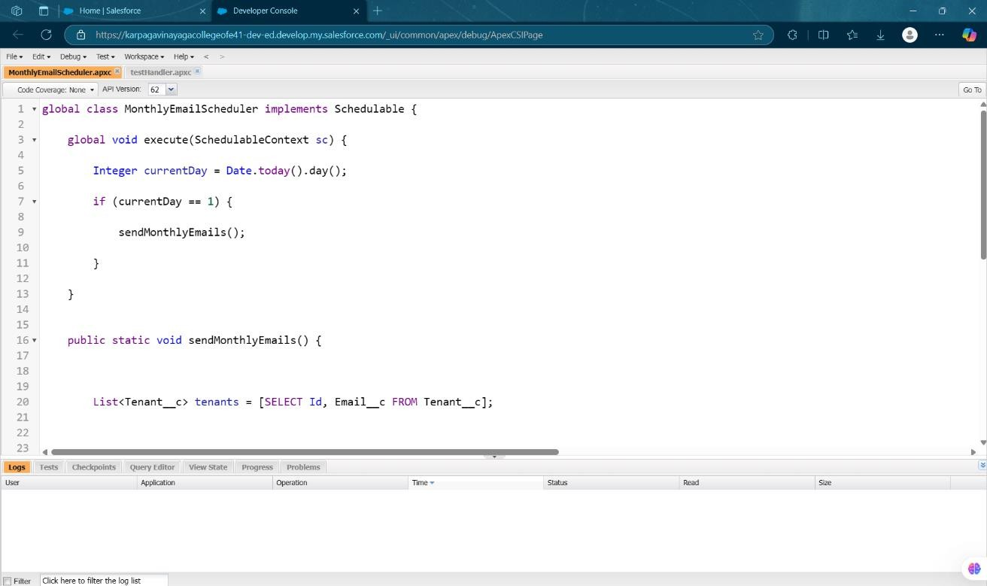

**Fig 1.12: Apex class – Monthly Email Schedular**

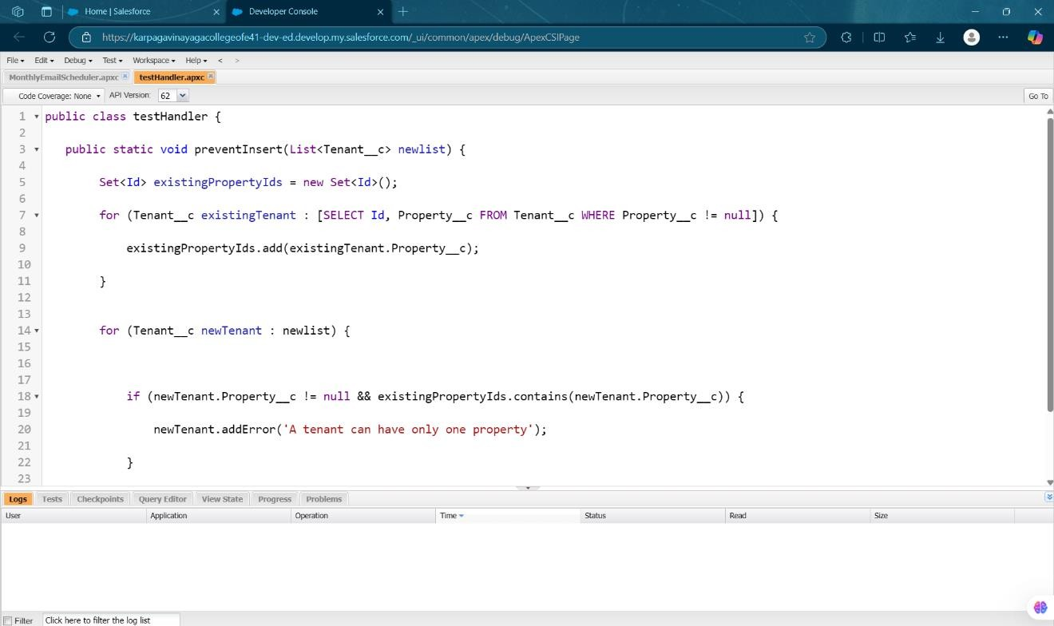

**Fig 1.13: Apex class – Test Handler**

 

### Apex Trigger Testing:

Apex triggers will be tested to ensure they fire correctly when certain actions occur (e.g., when a payment is overdue or a lease is renewed). We will validate that the triggers properly update records and send notifications.

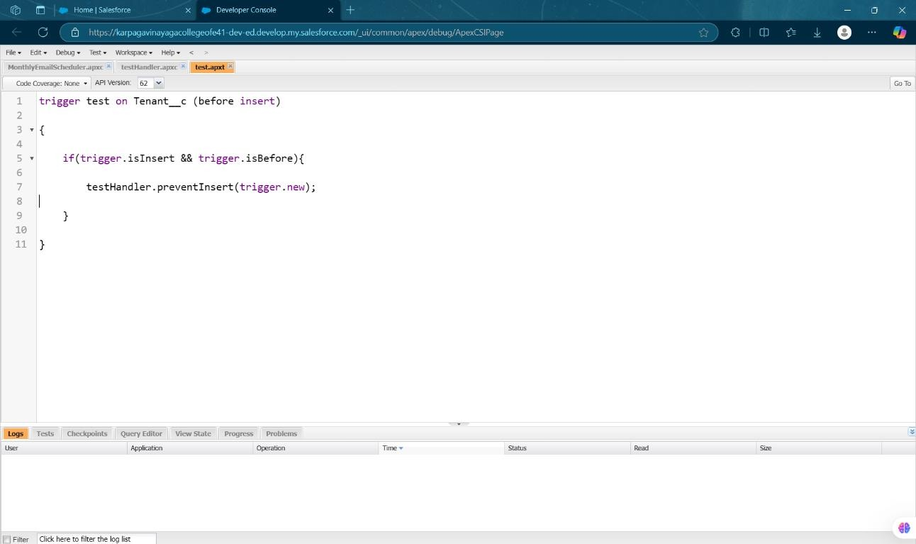

**Fig 1.14: Apex Trigger – Test**

### Test Cases:

Test cases will be written for each key function, such as:

* Creating a new lease and checking if the system calculates rent correctly.
* Triggering payment reminders and verifying if they are sent.

## User Interface Testing:

### UI Functionality Testing:

The UI will be tested to ensure all pages and features, like dashboards and lease details, function as intended. We’ll check if buttons and links work, and if data is displayed correctly.

 

**Fig 1.15: Tenant Approval Pending**

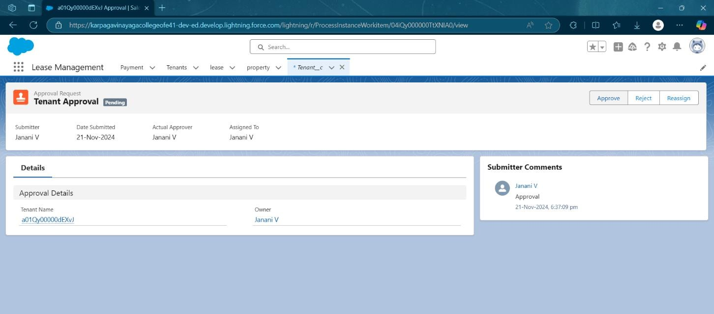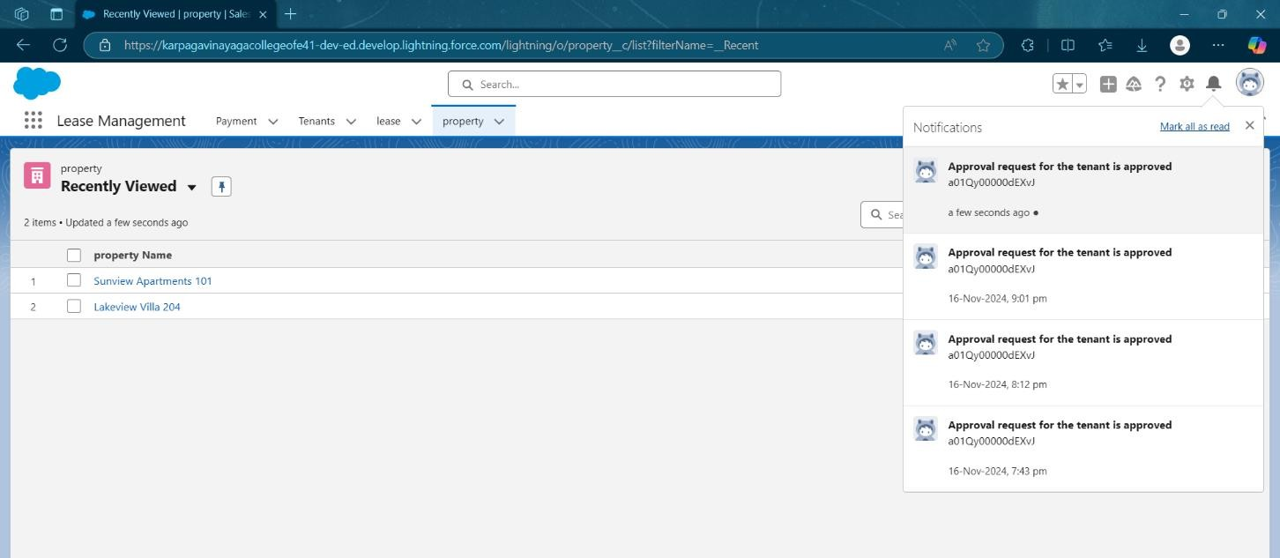

**Fig 1.16: Tenant Approval – Approved Notification**

### Usability Testing:

We will ensure that the system is user-friendly by asking real users (property managers and tenants) to test the interface and provide feedback. This includes testing the ease of navigation and the clarity of information presented.

### Responsive Testing:

We’ll test the UI across different screen sizes and devices to ensure it looks and works well on desktops and mobile devices.

 

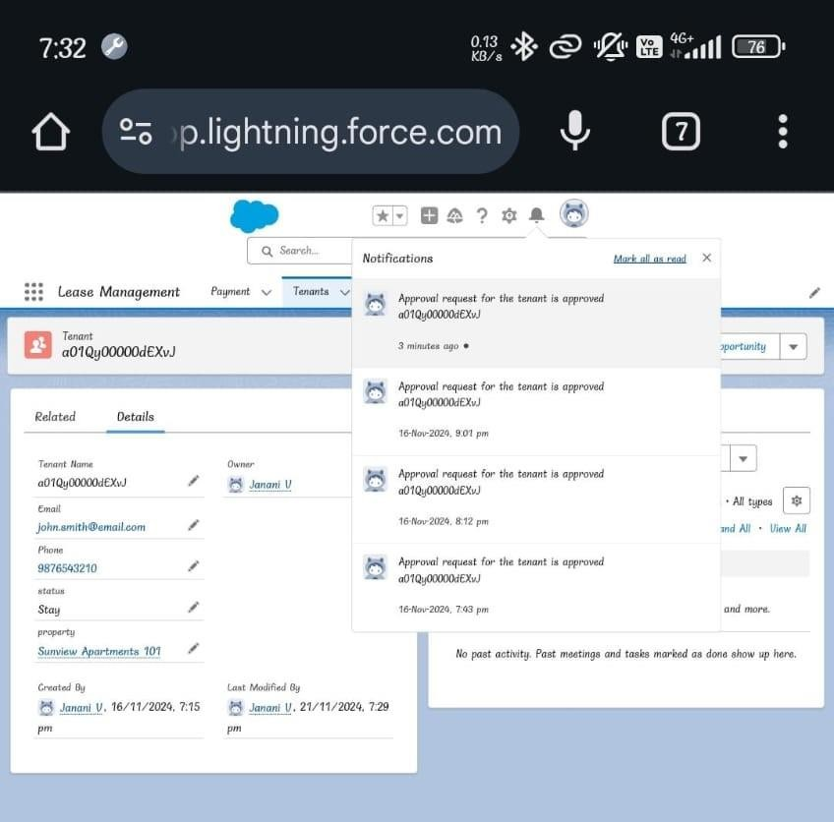

**Fig 1.17: Tenant Approval - Mobile Interface**

### Performance Testing:

* **Load Testing:**

The system will be tested for performance under various loads, ensuring that it can handle multiple users accessing the system simultaneously without performance degradation.

### Speed Testing:

We will evaluate the response times of the system, ensuring that pages load quickly, and actions (like submitting forms or generating reports) are completed efficiently.

 

# KEY SCENARIOS ADDRESSED BY SALESFORCE IN THE IMPLEMENTATION PROJECT:

### Lease Management Automation:

* + **Scenario:** Automating lease renewals and terminations.
  + **Salesforce Solution:** Salesforce sends automatic reminders for lease expirations and updates the lease details when renewed.

### Payment Tracking and Reminders:

* + **Scenario:** Tracking tenant payments and sending reminders.
  + **Salesforce Solution:** The system sends payment reminders to tenants and tracks overdue payments.

### Maintenance Request Management:

* + **Scenario:** Handling maintenance requests from tenants.
  + **Salesforce Solution:** Tenants submit requests that are assigned to property managers, who can track and update the status.

### Tenant and Property Data Management:

* + **Scenario:** Storing and managing tenant and property details.
  + **Salesforce Solution:** Salesforce custom objects store tenant, lease, and property information, making it easy to access and update.

### Report Generation and Dashboards:

* + **Scenario:** Creating reports and dashboards for easy tracking.
  + **Salesforce Solution:** Reports and dashboards help property managers view lease data, payment statuses, and maintenance progress.

 

### Security and Access Control:

* + **Scenario:** Controlling who can access the data.
  + **Salesforce Solution:** Role-based access ensures only authorized users can see specific data, keeping information secure.

# CONCLUSION:

The Lease Management System project was successfully developed to streamline the leasing process and provide efficient management of lease-related data. The system effectively automates critical tasks such as tracking lease agreements, managing payment schedules, and generating detailed reports. By addressing the challenges of manual lease tracking, the project delivers a robust solution that enhances productivity, minimizes errors, and ensures compliance with lease terms.

Summary of Achievements:

* **Efficient Lease Tracking:** Successfully implemented features to monitor lease agreements, including start/end dates, payment schedules, and renewal notifications.
* **Automation of Processes:** Reduced manual effort by automating key functions such as rent calculations, reminders, and reporting.
* **Improved Data Management:** Enabled centralized storage and easy access to lease information, ensuring accuracy and security.
* **Enhanced User Experience:** Delivered an intuitive and user-friendly interface that simplifies lease management for users.
* **Scalability and Flexibility:** Designed the system to accommodate future needs, such as integration with other business tools or modules.

This project marks a significant step forward in managing leases effectively, offering a practical and scalable solution for real-world applications.

 

# REFERENCE:

1. **Smart internz-** **https://apsche.smartinternz.com/Student/externships**
2. **Binary Stream -** [**https://knowledge.binarystream.com/complete-guide-**](https://knowledge.binarystream.com/complete-guide-lease-management)[**lease-management**](https://knowledge.binarystream.com/complete-guide-lease-management)
3. **Tango lease -** [**https://tangoanalytics.com/products/tango-lease/**](https://tangoanalytics.com/products/tango-lease/)
4. **Streamlined -** [**https://www.relayco.io/insights/salesforce-for-streamlined-**](https://www.relayco.io/insights/harnessing-the-power-of-salesforce-for-streamlined-property-management)[**property-management**](https://www.relayco.io/insights/harnessing-the-power-of-salesforce-for-streamlined-property-management)
5. **Salesforce -****https://orgfarm-02a4ecdb5a-dev-ed.develop.lightning.force.com/lightning/o/Payment_for_tenanat__c/list?filterName=__Recent**
6. **Case study lease accelerator -** [**https://explore.leaseaccelerator.com/resources/customers/salesforce-case-**](https://explore.leaseaccelerator.com/resources/customers/salesforce-case-study/)[**study/**](https://explore.leaseaccelerator.com/resources/customers/salesforce-case-study/)
7. **GitHub -**[**https://github.com/jaswanthchilamkurthi/Lease-Management-/tree/main**](Salesforce%20-%20Lease%20management%20project%20jaswanth.docx)